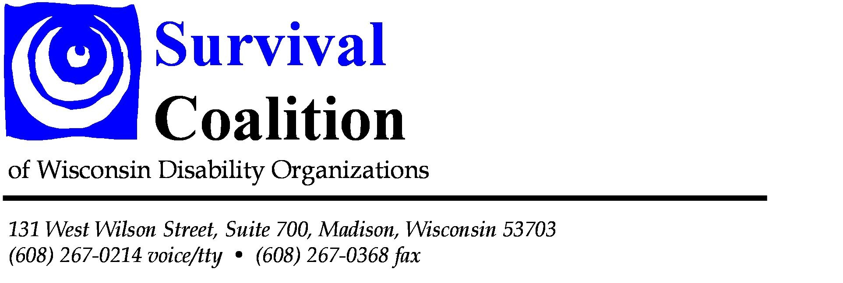

March 14, 2012

SURVIVAL COALITION CONGRATULATES LEGISLATURE ON PASSING BILLS TO SUPPORT PEOPLE WITH DISABILITIES

Assembly and Senate Pass Key Bills to Support People with Disabilities
  - AB 471 and SB 353 -- Intellectual Disabilities
  - AB 477 and SB 380 – Family Care Caps
  - AB 455 and SB 353 – Restraint and Seclusion

In the last two days the Assembly and Senate showed great bi-partisan leadership and cooperation by passing bills important to people with disabilities in Wisconsin. Each of these bills will have a personal impact on many individuals.

Specifically, we congratulate legislators for listening to their constituents with intellectual disabilities about the harmful impact of the R-Word and for removing this terminology from our state laws. “It will be a great day when this legislation is signed by Governor Walker,” says Survival Co-Chair Beth Swedeen. Both houses passed AB 471 and SB 377 by voice votes.

Secondly, we express our appreciation to both the Assembly and Senate for their action to pass the bill to lift the caps on Family Care. Representative Kaufert’s and Senator Moulton’s leadership in authoring this legislation and understanding the importance of eliminating waiting lists for people with disabilities and the elderly is to be commended. We look forward to seeing thousands of people with disabilities on waiting lists throughout our state finally benefit from the services and supports they need to maintain their independence in the community. “Advocates fought tirelessly to lift the caps since they were placed through the state budget in July,” says Survival Co-Chair, Maureen Ryan. “It is because of their tremendous effort and communication to their representatives and senators that we can celebrate today.” AB 477 and SB 380 passed by voice votes.

Finally, disability advocates and thousands of families across this state thank the Assembly for an extraordinary show of bi-partisanship in passing one of the toughest seclusion and restraint bills in the country. “Following years of work by disability advocates, stakeholders finally came together to pass this strong public policy that will protect students and teachers from harmful practices,” says Survival co-chair Tom Masseau. AB 455 and SB 353 passed by voice votes.

Survival Coalition Co-Chairs
Maureen Ryan, Wisconsin Coalition of Independent Living Centers, Inc; 608-444-3842; moryan@charter.net
Beth Swedeen, WI Board for People with Developmental Disabilities; 608-266-1166; Beth.Swedeen@wisconsin.gov
Tom Masseau, Disability Rights Wisconsin; 608-267-0214; Tom.Masseau@drwi.org

